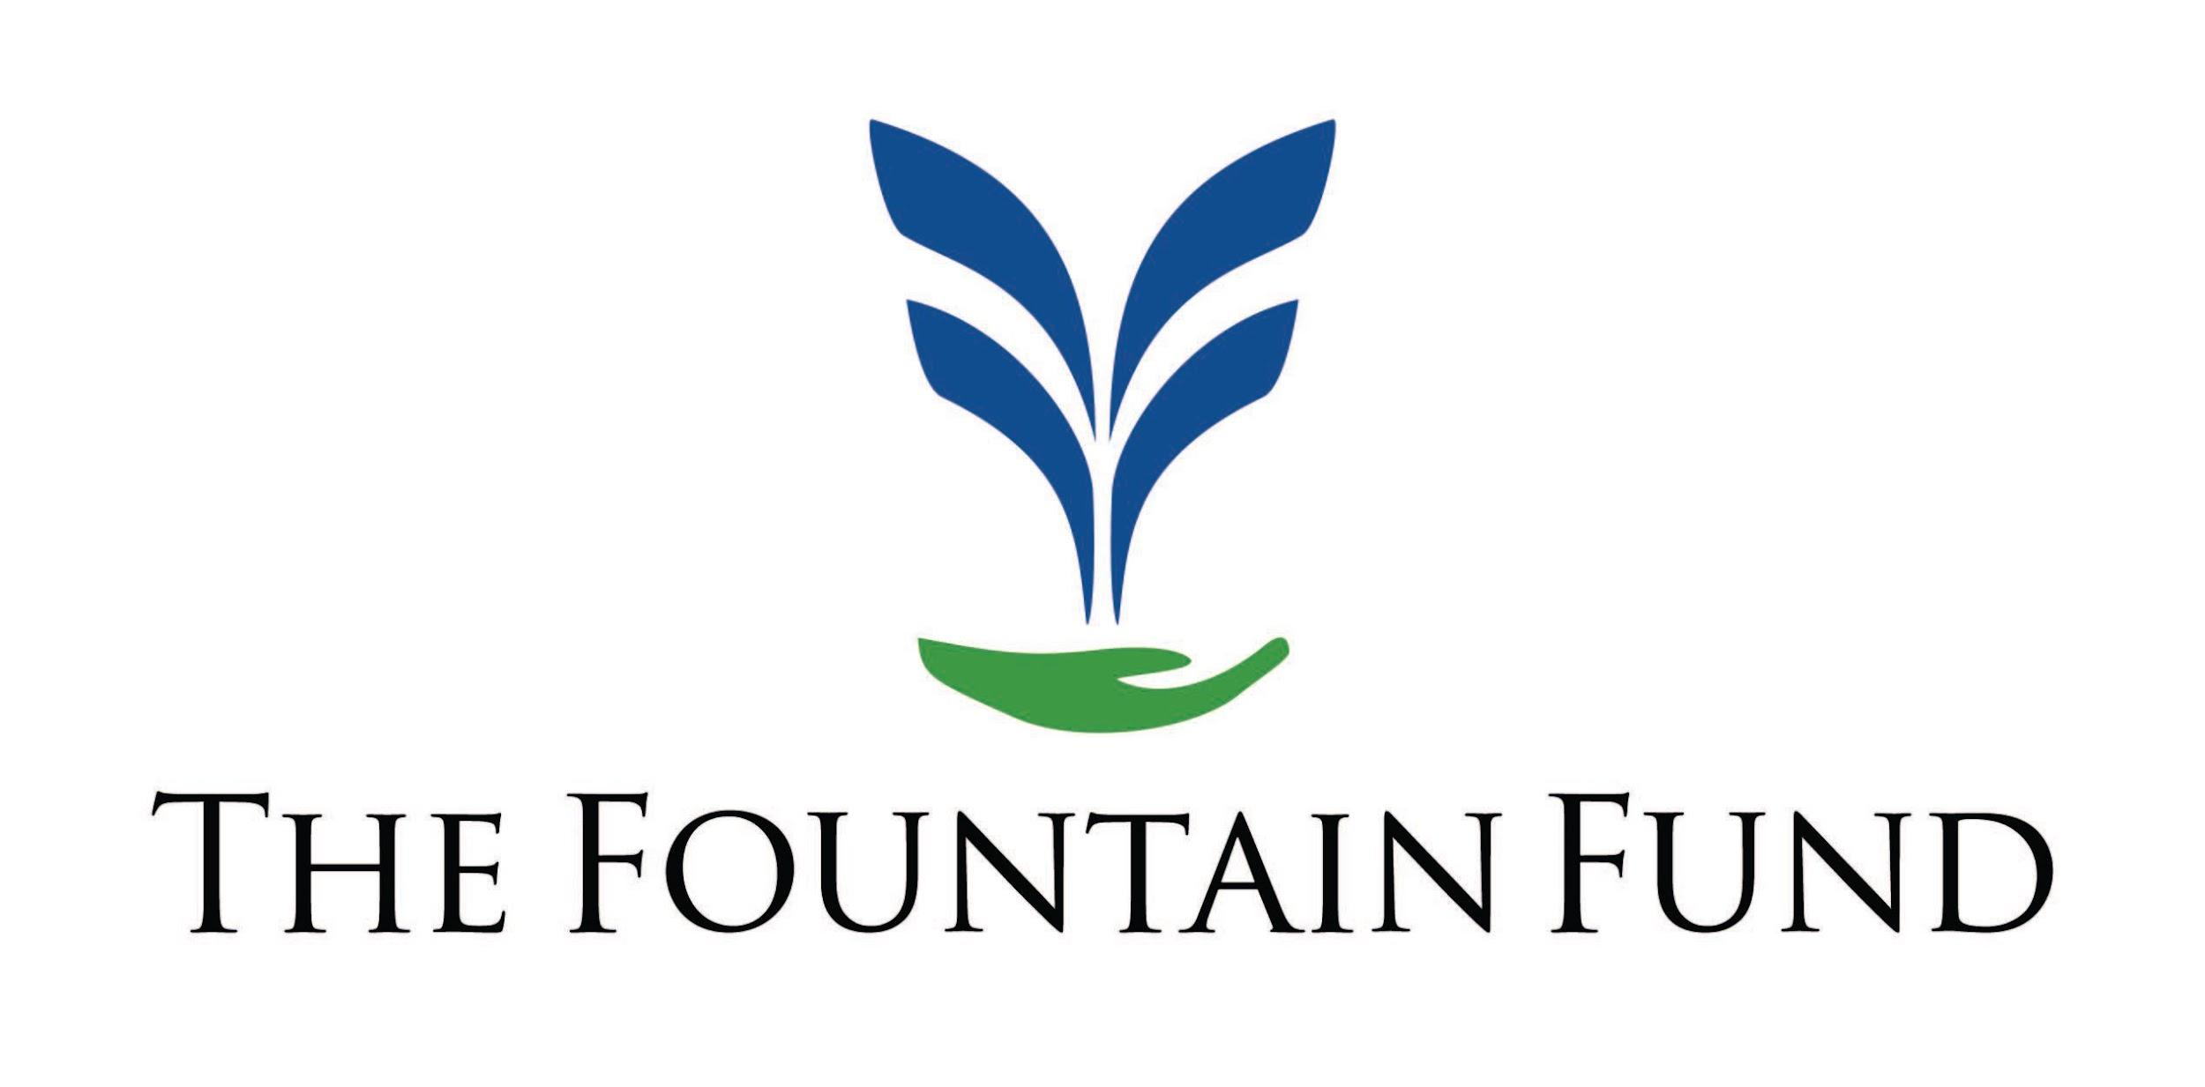

FOR IMMEDIATE RELEASE
September 16, 2025

The Fountain Fund’s Philadelphia Office
Reaches $1 Million Milestone in
Loans to Formerly Incarcerated Client Partners

Philadelphia, PA – The Fountain Fund’s Philadelphia site is pleased to announce that it recently surpassed the $1 million mark in loans made to its Client Partners. This is a significant milestone in fulfilling the agency’s mission of increasing economic opportunities for formerly incarcerated people to improve their lives and remain in their communities.

Since 2022, the agency’s Philadelphia office has provided 137 low-interest loans and financial coaching to more than 131 returning citizens. Support from the GreenLight Fund has been instrumental in the agency’s successful launch and emergence as leader in the reentry community.

Shares Michael Butler, Philadelphia Site Director, “Every person who receives a loan has a powerful story to tell. We see their disbelief turning into joy, the weight of anxiety lifted, the spark of hope reignited. We also hear gratitude for simply being given a chance.” He continues, “Today, we don’t just acknowledge that, we celebrate it. We celebrate this milestone in the heart of the City of Brotherly Love, where giving folks chances are honored, and where an organization has entrusted this sacred work to one of its own, someone who has carried the same scars of life behind the wall and now stands as proof of what is possible.”

The Fountain Fund believes that everyone they help stand strong is one less person caught in the cycle of a broken system. That’s REAL recidivism prevention. An inspiring example: Client Partner Tyree Wallace was incarcerated for 26 years for a crime he didn’t commit. In fall 2024, he returned home to begin life anew. His dream? To launch the Systemic Reformative Change Foundation, a nonprofit that is committed to transforming the systemic injustices that oppress marginalized communities. A $15,000 Fountain Fund loan is helping Tyree fulfill this longtime vision.

Stacey Torrance, Philadelphia Loan Administrator, works closely with Client Partners during the loan review process. He shares, “From someone who served three decades of a death by incarceration sentence, I know how it feels to have unfulfilled and unattainable dreams because you are invisible to financial institutions and the credit system. The Fountain Fund removes those barriers. Financial empowerment IS criminal justice reform.”

The Fountain Fund is headquartered in Charlottesville, VA. Founded in 2017, the nonprofit also provides services in Boston, MA; New Orleans, LA; Philadelphia, PA; and Richmond, VA.

Note: Press is invited to attend the RSVP only $1M Milestone Event taking place on October 14, 2025 from 5-7pm at Hopeworks Kensington, 3400 J Street, Philadelphia, PA.

For more information contact: Mike Butler (mbutler@fountainfund.org or 267.209.0042)

